➜ ~ dig @160.98.30.207 ourpc.lte07.ch

; <<>> DiG 9.10.3-P4-Ubuntu <<>> @160.98.30.207 ourpc.lte07.ch
; (1 server found)
;; global options: +cmd
;; Got answer:
;; ->>HEADER<<- opcode: QUERY, status: NOERROR, id: 1263
;; flags: qr aa rd ra; QUERY: 1, ANSWER: 1, AUTHORITY: 2, ADDITIONAL: 3

;; OPT PSEUDOSECTION:
; EDNS: version: 0, flags:; udp: 4096
;; QUESTION SECTION:
;ourpc.lte07.ch. IN A

;; ANSWER SECTION:
ourpc.lte07.ch. 86400 IN A 160.98.31.170

;; AUTHORITY SECTION:
lte07.ch. 86400 IN NS ourpc.lte07.ch.
lte07.ch. 86400 IN NS tlabs.tic.eia-fr.ch.

;; ADDITIONAL SECTION:
tlabs.tic.eia-fr.ch. 85548 IN A 160.98.31.32
tlabs.tic.eia-fr.ch. 85548 IN AAAA 2001:620:40b:1030::a062:1f20

;; Query time: 2 msec
;; SERVER: 160.98.30.207#53(160.98.30.207)
;; WHEN: Wed Nov 29 14:35:33 CET 2017
;; MSG SIZE rcvd: 148

; Haute ecole d'ingenierie et d'architecture de Fribourg
; Reseaux IP
; ---------------------------------------------------------------------------------
; TP DNS - Filename= ltexx.ch.zone
; ---------------------------------------------------------------------------------
; (c) F. Buntschu
;
; Version 1.4
; ---------------------------------------------------------------------------------
$ORIGIN lte07.ch.
$TTL 86400
@ IN SOA lte07.ch. root.lte07.ch. (
2015111601
3600
900
604800
86400 )

; Descriptions of names servers for this domain (primary and secondary)
IN NS ourpc.lte07.ch.
IN NS tlabs.tic.eia-fr.ch.

; List of known hosts in this domain
ourpc IN A 160.98.31.170
www IN CNAME ourpc
smtp IN CNAME ourpc
pop IN CNAME ourpc
lte07.ch. IN MX 10 pop.lte07.ch.

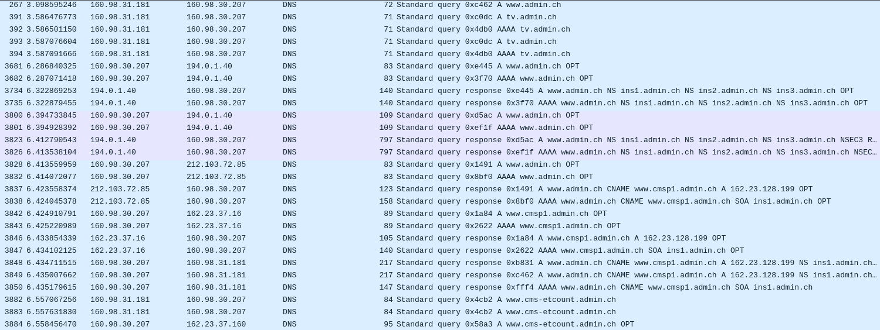
# whois ch
% IANA WHOIS server
% for more information on IANA, visit http://www.iana.org
% This query returned 1 object
domain: CH
organisation: SWITCH The Swiss Education & Research Network
address: Werdstrasse 2
address: Zurich CH-8021
address: Switzerland
contact: administrative
name: SWITCH TLD Administration
organisation: SWITCH The Swiss Education & Research Network
address: Werdstrasse 2
address: Zurich CH-8021
address: Switzerland
phone: +41 44 268 15 40
fax-no: +41 44 268 15 78
e-mail: tld-admin@switch.ch
contact: technical
name: Security Engineer
organisation: SWITCH The Swiss Education & Research Network
address: Werdstrasse 2
address: Zurich CH-8021
address: Switzerland
phone: +41 44 268 15 40
fax-no: +41 44 268 15 78
e-mail: dns-operation@switch.ch
nserver: A.NIC.CH 130.59.31.41 2001:620:0:ff:0:0:0:56
nserver: B.NIC.CH 130.59.31.43 2001:620:0:ff:0:0:0:58
...
nserver: H.NIC.CH 2a03:bd80:36:0:0:1:203:230 85.119.5.230
ds-rdata: 58852 8 2 A14E7E746D70F96F0AA20B326C5903F294AACB2C8C720B73CA369FE611F565C4
whois: whois.nic.ch
status: ACTIVE
remarks: Registration information: http://www.nic.ch/
created: 1987-05-20
changed: 2017-11-30
source: IANA

